**Task 5. Microsoft Disk Operating System (MS-DOS) Commands**

**Introduction:**

**Directory***:* A catalog for filenames and other directories stored on a disk.

**File:** A named collection of data stored on disk, appearing to the user as a single unit. It is a group of related records in a database. In relational database, it is called as ‘Table’.

**NOTE: DOS is not case sensitive (i.e. DOS commands can be entered in uppercase or lowercase)**

* **Types of DOS Commands**

MS DOS commands mainly categorized into 2 types

1. Internal Commands

2. External Commands

1. **Internal Commands**

🡪These commands are generally loaded when an operating system itself is loaded into the memory. So these commands are stored in computer main memory.

Ex: DIR, COPY, DEL, REN, MD, CD, RD, REN etc.

🡪Internal commands are also known as *‘Intrinsic Commands’*.

**2. External Commands**

* 🡪These Commands are stored in Disk files. Stored in secondary memory like disk.
* Ex: SYS, TREE, XCOPY, FORMAT, DISKCOPY, CHKDSK, LABEL etc.
* 🡪External commands are also known as *‘Extrinsic Commands’*.
* **How to start DOS**
* Start -> Programs -> Accessories -> Command Prompt
* (or) Start -> Run… -> enter ‘cmd’ or ‘command’ in the text box
* **File Naming Conventions**
* A filename has 2 parts:

(a) Primary Name

(b) Secondary Name (Extension)

* A dot (.) separates a primary name from extension.
* Ex: anitha.doc
* It is optional to give an extension to a filename.
* 1. Primary name cannot have more than 8 characters and extension can have a maximum of 3 characters

2. A filename can contain the following characters:

• An Alphabet (A-Z) or (a-z)

• A number (0-9)

• Special Characters such as $, #, &, @, !, %, (, ), ~, {, }, ‘, ^ etc

except *, ?,fullstop (.) and space ( )

* **Internal/Intrinsic Commands**
* **Directory Manipulation Commands of DOS**

1. **DIR command :**

**Purpose:**  it displays a list of files or directories present on a disk.

**Syntax:** D:\> DIR <Enter>

It displays

1. Primary Name

2. Extension

3. Size of each file in bytes

4. Date when the file was either created or modified last

5. Time when the file was either created or modified last

Ex:D:\> Dir

**Output:**

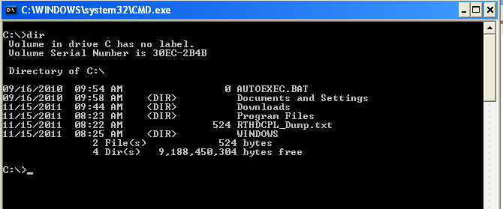

* **Ex:** D:\>DIR/P -> it shows the contents of the disk page-wise
* **Ex:** D:\>DIR/W -> it shows the contents of the disk width-wise. It displays only filenames not date, time, size of file etc. directories are shown in square brackets ([ ]).
* Ex: DIR/A– Display files with specified attributes.
* Ex: DIR/D – same as wide but files are list sorted by column.
* Ex: DIR/Q – Display owner of the file

**2. MD command :**

**Purpose:**  is used to create (make) a directory

**Syntax:** D:\>MD <directory-name>

**Ex:D:\>md SNIST**

**Output:**

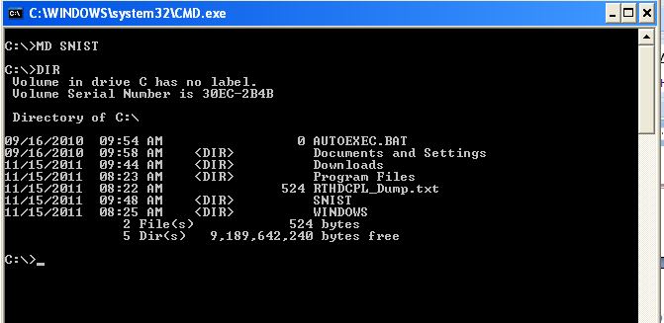

**Ex:** D:\>MD mechB2**\**mech1-> it creates a sub-directory ‘mech1’ under ‘mechB2’ directory

**3. RD command :**

**Purpose:** to remove (delete) a directory

**Syntax:** D:\>RD <directory-name>

**Ex:** D:\>RD SNIST

**Output:**

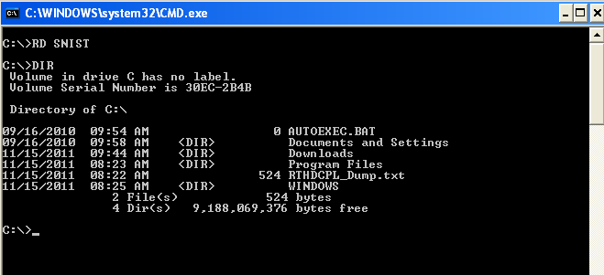

* **NOTE:** A directory or sub-directory has to be empty before removing it.

**4. CD command :**

**Purpose:** To change directory

**Syntax:** D:\>CD <directory-name>

**Ex:** C:\>CD SNIST -> it change to ‘SNIST’ directory

**Output:**

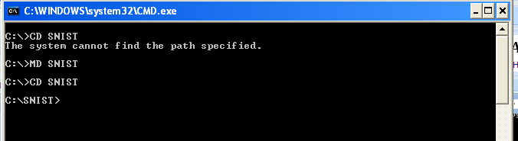

C:\>CD SNIST\CSE\CSEE3

**Output:**

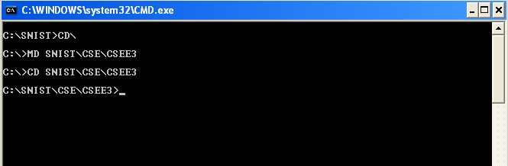

**NOTE:**

D:\>CD\ -> it goes to root directory (from any level)

D:\>CD.. -> it goes only one level up

D:\>CD -> it displays current directory name

D:\>CD <directory-name> -> to change directory

* **File Manipulation Commands of DOS**

1. **COPY command:**

**Purpose: T**o copy a file

**Syntax:** COPY <source drive> <destination file>

**Ex: C:\>SNIST\CSE\CSEE3>COPY SNIST.TXT CSE.TXT**

**Output:**

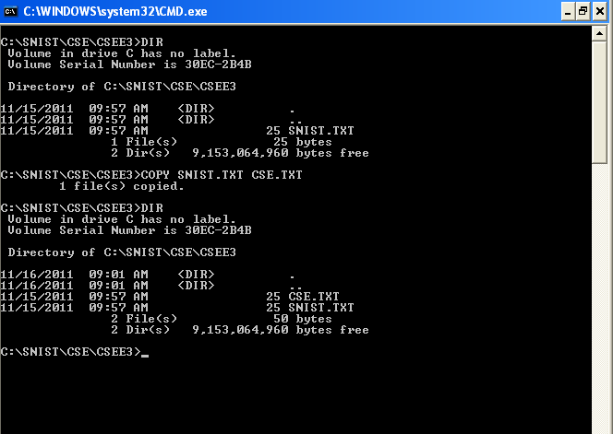

**Syntax:** COPY <source drive>:<file spec1> <target drive>:<file spec2>

Ex: C:\S**NIST\CSE\CSEE3>COPY CSE.TXT D:\CSE1.TXT**

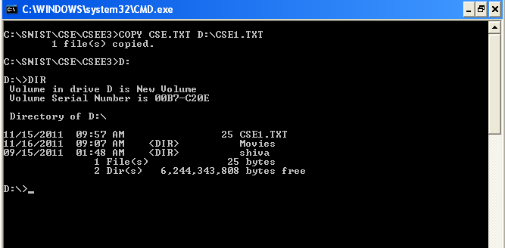

**2. DEL command:**

**Purpose: T**o delete a file

**Syntax:** C:\>DEL <filename>

**Ex:** C:\S**NIST\CSE\CSEE3>DEL CSE.TXT**

**Output:**

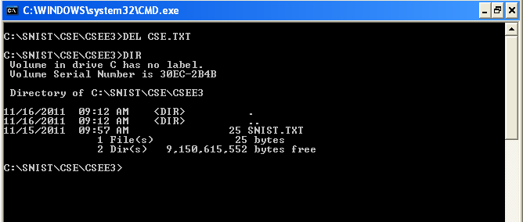

**3. REN command :**

**Purpose: T**o rename a file

**Syntax:** C:\>REN <old-filename> <new-filename>

**Ex:** C:\S**NIST\CSE\CSEE3>REN SNIST.TXT CSEE3.TXT**

**Output:**

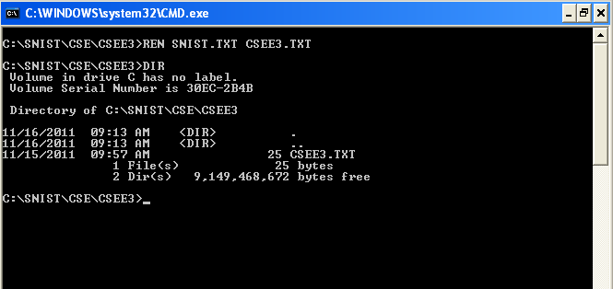

* **Commonly used DOS commands:**

1. **DATE command :**

**Purpose: I**t displays system date

**Syntax:** C:\>DATE

**Ex:** C:\S**NIST\CSE\CSEE3>DATE**

**Output:**

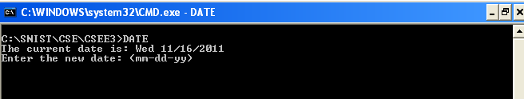

If user enters new date, it changes system date

**2. TIME command :**

**Purpose: I**t displays system time

**Syntax:** C:\>TIME

Ex:C:\S**NIST\CSE\CSEE3>TIME**

**Output:**

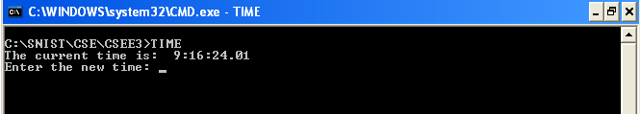

If user enters new time, it changes system time

**3. CLS command :**

**Purpose: To** clear the screen

**Syntax:C:\CLS**

Ex: C:\S**NIST\CSE\CSEE3>CLS**

**Output:**

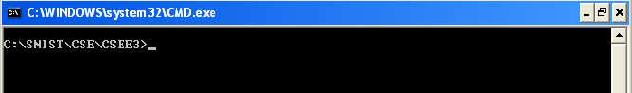

**4. COPY CON command:**

**Purpose: T**o create a file at command prompt

**Syntax:** C:\>COPY CON <filename>

**Ex:** C:\S**NIST\CSE\CSEE3>COPY CON SNIST.TXT**

**Output:**

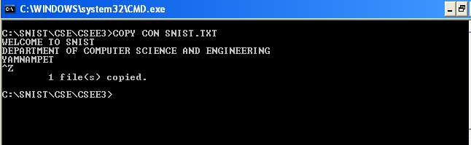

Note: Press CTRL+Z to save and exit command

**(ii). EDIT command** -> to create a file in DOS editor

**Syntax:** C:\>EDIT <filename>

**Ex:** C:\S**NIST\CSE\CSEE3> CSEE3.TXT**

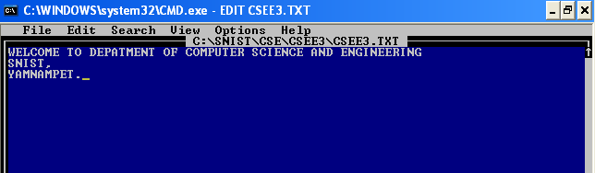

**5. TYPE command** -> to view the contents of a file

**Syntax:** C:\>TYPE <filename>

* **Ex:** C:\S**NIST\CSE\CSEE3> TYPE CSEE3.TXT 🡪** it displays the contents of CSEE3.TXT file on the screen

**Output:**

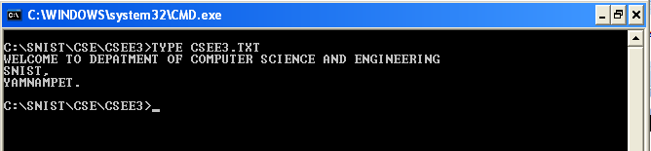

**6. ECHO Command:**

**Purpose:** to display a message on the screen while executing a set of commands.

**Syntax:** C:\> Echo <message>

**Ex**: C:\>Echo welcome to **snist**

**Output: welcome to snist**

* **External/Extrinsic Commands (Disk Manipulation Commands)**

1. **FORMAT command :**

**Purpose: I**t is used for formatting a hard disk or floppy disk

**Syntax:** C:\>FORMAT A:

**Ex:** C:\>FORMAT A:/S -> with this command, all the OS files (COMMAND.COM and 2 hidden files) are copied from the hard disk to the floppy disk.

**NOTE:** This command needs the program file FORMAT.COM

Format -> The organization of disk into tracks and sectors is called Formatting.

**2. CHKDSK command :**

**Purpose:** to check the status of the disk.

**Syntax:** C:\>CHKDSK A:

**NOTE:** If no drive letter is specified with CHKDSK command, then the currently active drive is checked.

3**. LABEL command**:

**Purpose:** A volume label to the disk is given at the time of formatting the disk.

**Syntax:** C:\> LABEL A:

**NOTE:** This command needs the program file LABEL.COM

4. **DISKCOPY command**:

**Purpose:** it copies all the contents of one disk onto the other.

**Syntax:** C:\> DISKCOPY A: A:

**NOTE:**

**1.** if there is a single drive on the computer, then the same can act as source as well as destination .

2. This command needs the program file DISKCOPY.COM

3. DISKCOPY command works with floppy disk and not with hard disk and both floppies should of same capacity.

**Task 6. LINUX Commands**

**1. ls Command:**

**Ex:** $ ls -> it displays list of files & directories

**Output:**

Desktop dwhelper Music Public Templates

Documents examples.desktop Pictures snist.c Videos

* $ ls -l -> it displays list of files & directories with permissions (r, w, x permissions)

**2. mkdir command:**-- to create a new directory

**Syntax**: #mkdir <directory-name>

**Ex:** #mkdir mechb2

**Output:**

Desktop dwhelper mechb2 Pictures snist.c Videos

Documents examples.desktop Music Public Templates

**3. rmdir command:**-- to remove a directory

Syntax: #rmdir <directory-name>

Ex: #rmdir mechb2

**Output:**

Desktop dwhelper Music Public Templates

Documents examples.desktop Pictures snist.c Videos

**4. cd command**: -- to change directory

Syntax: #cd <directory-name>

Ex: #cd MechB2

* cd\ -> to go to root directory

Syntax: #cd\

**5. rm command** -> to remove a file

Syntax: #rm <file-name>

**Ex**: #rm snic.c

**Output:**

Desktop dwhelper Music Public Templates

Documents examples.desktop Pictures snist.c Videos

6. **cp command** -> to copy a file

**Syntax:** #cp <file-name1> <file-name2> -> it copies contents of file1 to file2

**Ex:** #cp snist.c snis.c -> it copies contents of snist.c file to snis.c file

**Output:**

Desktop dwhelper Music Public snist.c Video

Documents examples.desktop Pictures snis.c Templates

**7. mv command ->** to rename a file

**Syntax**: #mv <file-name1> <file-name2>

**Ex:** D:\>mechB2\mech1\mech2>mv snis.c snist.c

**Output:** Desktop dwhelper Music Public Templates

Documents examples.desktop Pictures snist.c Videos

**8. cat command ->** to create a file, display a file, join 2 files, join 2 files and create a new

file and keep whole content in new file

**(i). Syntax**: #cat><file-name> -> to create a file

**Ex:** #cat> MechB2

Enter the text and press <Ctrl+Z> keys together to save file. Ctrl+Z keys tell operating system that no more text is going to be entered.

**(ii). Syntax:** #cat <file-name> -> it displays the contents of a file

**Ex:** #cat MechB2

(**iii). Syntax:** #cat <file-name1> <file-name2> -> it concatenates (joins) 2 files file1, file2

**Ex:** #cat MechB2 MechB1

**(iv). Syntax**: #cat <file-name1> <file-name2>><file-name3> -> it concatenates (joins) 2 files

file1, file2 and creates a new file (file3) and put the whole content in new file

**Ex**: #cat MechB2 MechB1>Mech

**9. vi command** -> to create a file in Linux editor (vi editor)

**Syntax**: #vi <filename>

**Ex**: #vi MechB2.txt

**Note:**

1. :w (or) :w! -> it saves a file and still remains in that file

2. :q (or) :q! -> it quits ‘vi’ editor without saving

3.:wq (or) :wq! (or) ZZ -> it saves a file and quits ‘vi’ editor

**10. grep command** -> to search for a specified pattern in a file such as a particular word or phase

**Syntax**: #grep <text> <file-name>

**Ex**: #grep SNIS MechB2

**11. sort command** -> to sort the contents of a file

Syntax: #sort <file-name>

Ex: #sort MechB2

**12. lp command ->** printing files

Syntax: #lp <file-name>

Ex: #lp MechB2

Ex: #lp MechB2 MechB1 -> it prints 2 files

NOTE: User can print more than 1 file using single lp command

**Linux Utilities:**

**1. banner command** -> it makes posters

Syntax: #banner <text>

Ex: #banner KIT

**2. cal command** -> it displays calendar

Syntax: #cal

**Output:**

January 2011

Su Mo Tu We Th Fr Sa

1

2 3 4 5 6 7 8

9 10 11 12 13 14 15

16 17 18 19 20 21 22

23 24 25 26 27 28 29

30 31

Ex: #cal -> it displays current month calendar

Ex: #cal 2004 -> it displays all 12 months of 2004

**3. date command** -> it displays date & time

Syntax: #date

To display current date

Ex: snist@snist-desktop:~$ date

**Output:**

Wed Jan 19 12:46:24 SCT 2011

**4. who command** -> it prints the login name of the person on the system

Syntax: #who

Ex: snist@snist-desktop:~$ who

**Output:**

ravi tty7 2011-01-19 12:32 (:0)

ravi pts/0 2011-01-19 12:36 (:0.0)

**5. tty command ->** it displays the name of the terminal

Syntax: #tty

Ex:snist@snist-desktop:~$ tty

**Output:**

/dev/pts/0

**6. uname command ->** it displays name of the current Linux system

Syntax: #uname

Ex:snist@snist-desktop:~$ uname

**Output:**

Linux

**7. Echo command:**

Syntax: #echo <text>

Ex: #echo SNIST

**Output:**

SNIST

**8. pwd command ->** it prints working directory

Syntax: #pwd

Ex: snist@snist-desktop:~$ pwd

**Output:**

/home/ravi

**9. man command ->** it displays on line help

Syntax: #man

**10. clear command ->** to clear the screen

Syntax: #clear the terminal

**11. wc command** -> it displays no. of lines, words, characters of a file

Syntax: #wc <filename>

Ex: snist@snist-desktop:~$ wc snist.c

**Output:**

1 1 8 snist.c